Name: Arsh Raj

Employee ID: 655026

Email: [Arsh.Raj@shell.com](mailto:Arsh.Raj@shell.com)

Batch: Shell7-SK-23-B4

Reg ID: SH7B23110

**Requirement 1: Data Loading**

Creating Database and Tables in SQL Server

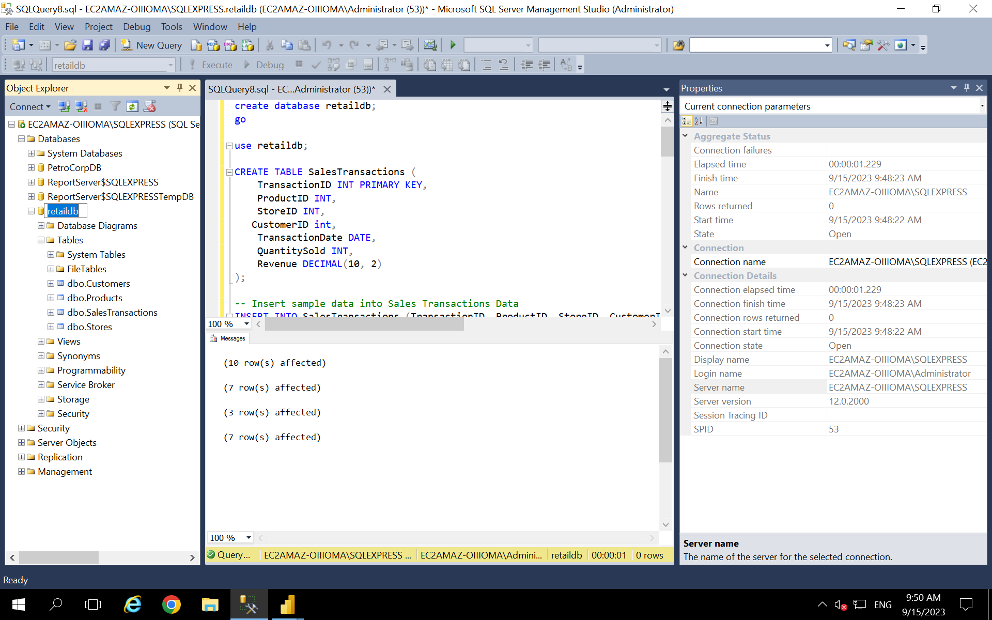

#Data Loading in PowerBI

Requirement 2: Data Transformation

Requirement 3: Data Modelling

# Creating Hierarchy: Category -> ProductName

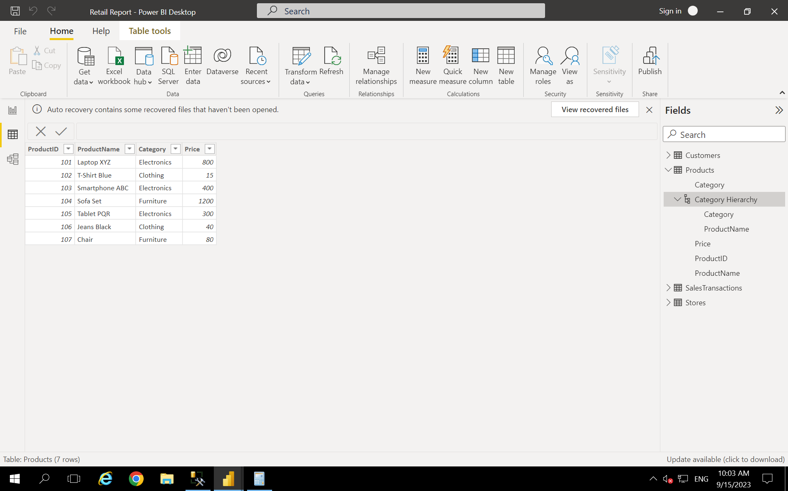

Requirement 4:

1,2

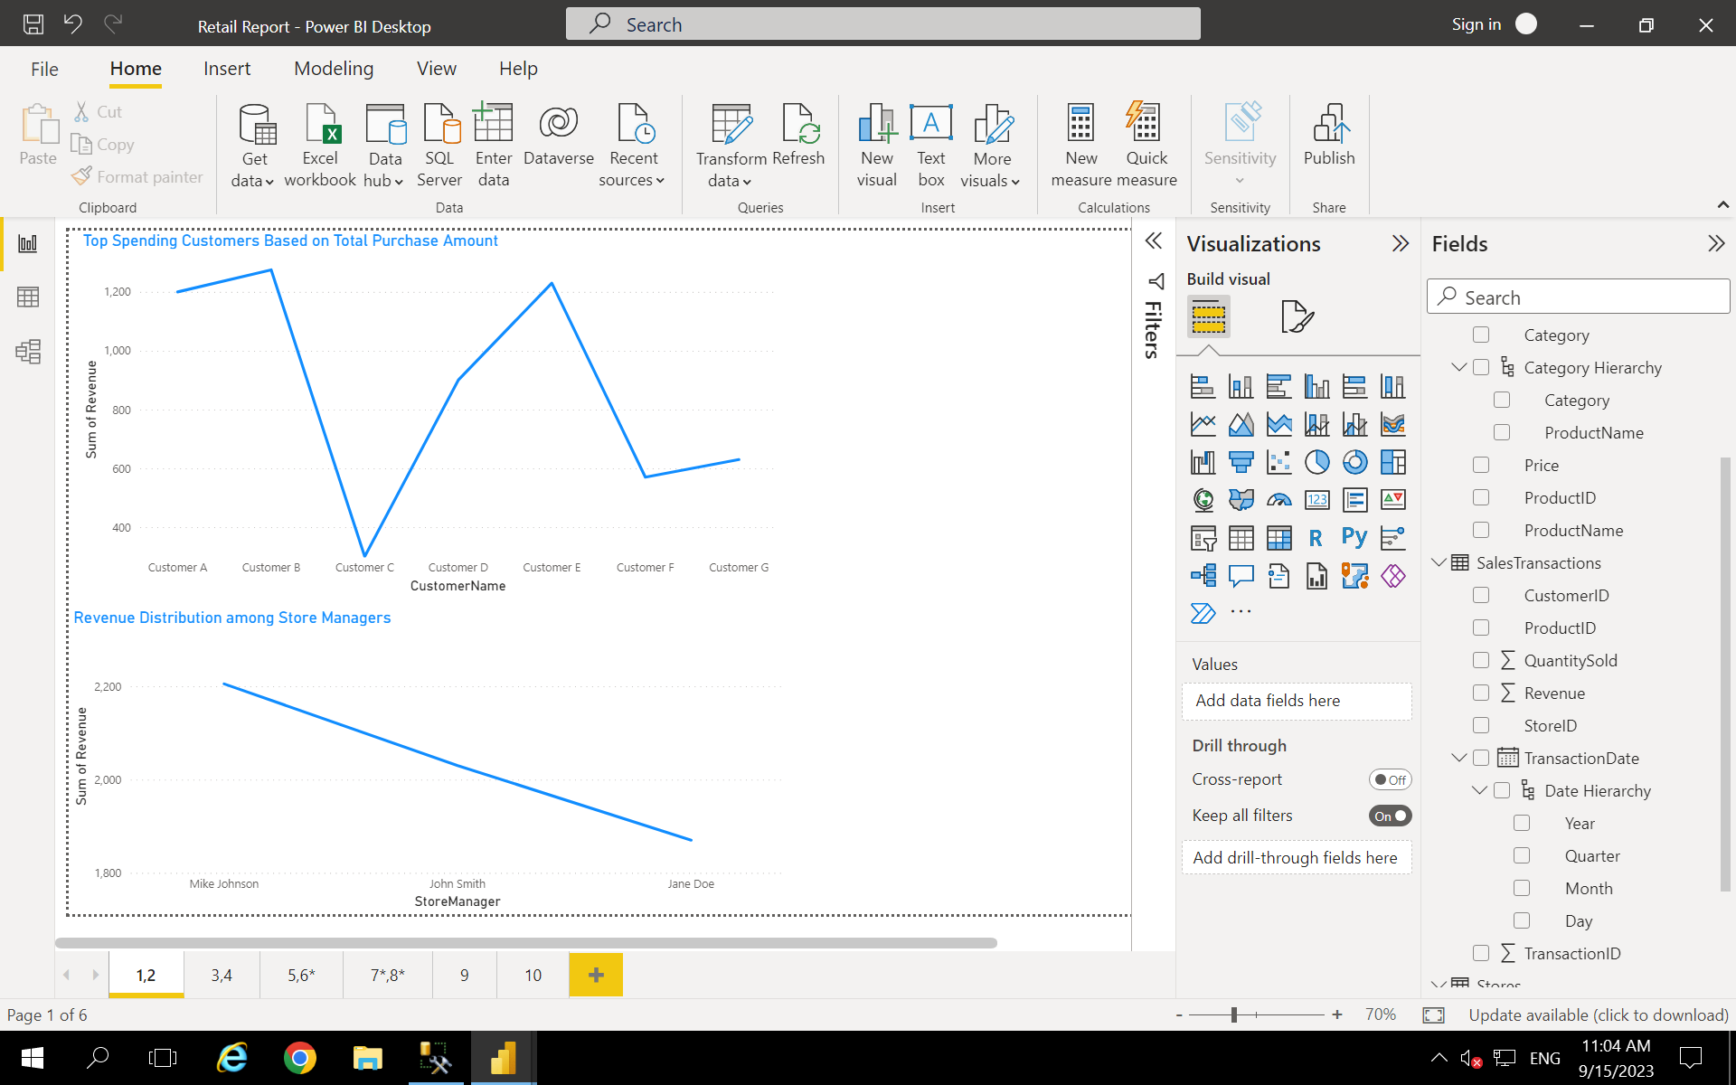

3,4

5,6

8

9

10

